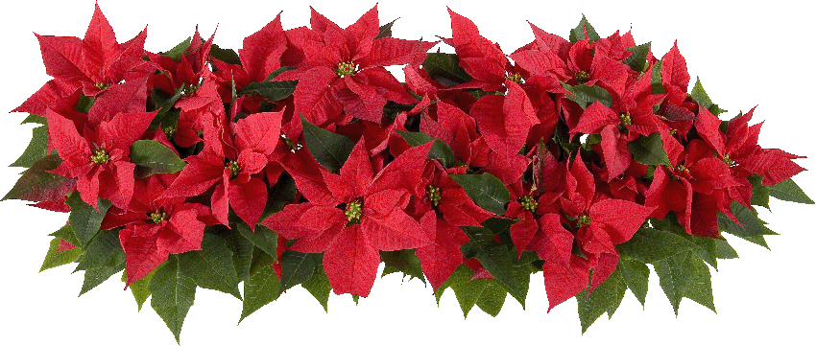
Fun Facts about
The Poinsettia
Euphorbia pulcherrima

(Related plants include cassava, castor bean, pencil cactus, and croton – some of these are edible, some are poisonous - which is probably why people think poinsettia is poisonous… but Poinsettia is Not Poisonous!)
- Joel Poinsett, U.S. Minister (Ambassador) to Mexico and Latin American Diplomat, brought Poinsettia cuttings to his home in Charleston, S.C. in 1829 and introduced it to a fellow horticulturist to grow as a floriculture crop.
- What we admire in poinsettias are actually specialized leaves, called bracts. The flower is a tiny, yellow cyathia in the center of the bracts.
- Contrary to popular belief, Poinsettias are not poisonous (scientifically proven at OSU), although their milky, latex sap is sometimes an irritant. (If you have a latex allergy, you might react to the sap.)
- Poinsettias are not poisonous to cats or dogs! (There are houseplants that are poisonous, but not Poinsettias.)

- Poinsettias are a short day plant, and bloom at different times of the year in different countries. Spain calls poinsettia the Pasque flower for Easter.
- In Mexico, poinsettias grow 10 to15 feet tall.
- In Wisconsin, poinsettia is grown as a houseplant.
- Poinsettias are the best-selling potted plant in the United States and Canada. More than 35 million poinsettias are sold each year.

